**“Virtual Mouse Using Hand Gestures”**

***A***

***Project Report***

*submitted in partial fulfillment of the*

*requirements for the award of the degree of*

**MASTER OF COMPUTER APPLICATION**

**WITH SPECIALIZATION IN**

**ARTIFICIAL INTELLIGENCE AND MACHINE LEARNING**

**by**

|  |  |
| --- | --- |
| **Name** | **SAP ID** |
| **Muhammad Saami** | **500125581** |
|  |  |
|  |  |

***under the guidance of***

**Dr. Chandra Mani Sharma**



**School of Computer Science**

**University of Petroleum & Energy Studies**

**Bidholi, Via Prem Nagar, Dehradun, Uttarakhand**

**December – 2024**

**CANDIDATE’S DECLARATION**

I/We hereby certify that the project work entitled **“Virtual Mouse Using Hand Gestures”** in partial fulfilment of the requirements for the award of the Degree of BACHELOR OF TECHNOLOGY in COMPUTER SCIENCE AND ENGINEERING with specialization in <SPECIALIZATION) and submitted to the Department of Systemics, School of Computer Science, University of Petroleum & Energy Studies, Dehradun, is an authentic record of my/ our work carried out during a period from **September**, **2024** to **December**, **2024** under the supervision of **Dr. Chandra Mani Sharma.**

The matter presented in this project has not been submitted by me/ us for the award of any other degree of this or any other University.

**Abhishek Singh Chauhan, Muhammad Saami, Khempal**

**Sap ID.: 500125001, 500125581, 500125754**

This is to certify that the above statement made by the candidate is correct to the best of my knowledge.

Date: _____________2024 **Dr. Chandra Mani Sharma**

Project Mentor

**ACKNOWLEDGEMENT**

We wish to express our deep gratitude to our mentor **Dr. Chandra Mani Sharma**, for all advice, encouragement and constant support he/she has given us throughout our project work. This work would not have been possible without his support and valuable suggestions.

We sincerely thanks to our respected **Name of HoD,** **Head Department of _____________,** for his great support in doing our project in **_____________________.**

We are also grateful to Dean SoCS UPES for giving us the necessary facilities to carry out our project work successfully. We also thanks to our Course Coordinator, (NAME) and our Activity Coordinator (NAME) for providing timely support and information during the completion of this project.

We would like to thank all our **friends** for their help and constructive criticism during our project work. Finally, we have no words to express our sincere gratitude to our **parents** who have shown us this world and for every support they have given us.

|  |  |  |  |  |
| --- | --- | --- | --- | --- |
|  |  |  |  |  |
|  |  |  |  |  |

**Abstract**

The virtual mouse using hand gestures represents a significant step forward in human-computer interaction, offering a touch-free, intuitive alternative to traditional input devices. This system leverages computer vision and machine learning technologies to recognize hand gestures and translate them into mouse operations such as cursor movement, clicking, scrolling, and dragging.

By utilizing a standard webcam for input and integrating libraries like OpenCV, Mediapipe, and PyAutoGUI, the system processes real-time video streams to detect and classify hand gestures with high accuracy. The proposed solution is not only accessible but also addresses key challenges like hygiene in healthcare environments and usability for individuals with physical disabilities.

The system design focuses on real-time performance, accuracy across diverse lighting conditions, and robustness in handling background complexity. Future enhancements include integrating depth sensors for improved tracking, voice command capabilities, and mobile platform optimization.

This project demonstrates the practicality of gesture-based interaction systems, paving the way for more immersive, hygienic, and accessible computing experiences across various applications, including healthcare, gaming, and virtual reality.

**TABLE OF CONTENTS**

**S.No. Contents Page No**

1. **Introduction 7 - 10** 
   1. History
   2. Requirement Analysis
   3. Main Objective
   4. Sub Objectives

1. **System Analysis 10 - 17**
   1. Existing System
   2. Motivations
   3. Proposed System
   4. Modules
2. **Design 18 - 22** 
   1. Use Case model for Requirement Analysis
   2. Conceptual Architecture
   3. Object and Class Design
   4. Sequence Diagram
   5. Activity Diagram

1. **System Components 23 - 28**
   1. Overview
   2. Gesture Recognition Algorithm
   3. Flowchart of Gesture Recognition
2. **Implementation 29 - 32**
   1. Cursor Movement
   2. Gesture-Based Actions
   3. Scenarios

1. **Limitations and Future Enhancements 33 - 36**
2. **Conclusion 37 - 38**
3. **References 39**

**LIST OF FIGURES**

**S.No. Figure Page No**

1. **Chapter 2**

Figure 2.1: Hand Land Marks 14

1. **Chapter 3**

Figure 3.1: Use Case Diagram 19

Figure 3.2: Conceptual Architecture 19

Figure3.3: Class Diagram 21

Figure3.4: Activity Diagram 21

Figure3.5: Sequence Diagram 22

1. **Chapter 4**

Figure 4.1: Flowchart of Gesture Recognition 28

**1. INTRODUCTION**

**1.1 History**

Gesture-based control has been an integral area of research in human-computer interaction (HCI) since the early days of technological innovation. The journey began with the need for natural and intuitive interfaces that could bridge the gap between human actions and machine responses. Here is a detailed overview of its evolution:

**Early Developments**

The earliest methods of gesture-based control relied heavily on mechanical and electrical devices. These included:

* **Joysticks and Trackballs**: Widely used in gaming and industrial applications, these devices allowed users to manipulate on-screen elements using physical movements. While effective, they were not intuitive or natural in mimicking human gestures.
* **Sensor-Equipped Gloves**: In the 1980s and 1990s, researchers introduced devices like data gloves, which came equipped with motion and flex sensors to capture hand and finger movements. These gloves enabled users to interact with virtual environments by translating physical movements into digital signals. However, they were expensive, cumbersome, and required extensive calibration.

**Advancements in Vision-Based Systems**

The limitations of early devices spurred the search for more seamless and touch-free solutions. The introduction of **computer vision technologies** in the 1990s marked a significant turning point. Vision-based systems eliminated the need for physical contact or specialized equipment, relying instead on cameras and image processing algorithms.

* **Optical Flow Techniques**: These methods analyzed the motion of objects in a video feed, allowing basic tracking of hand movements. However, they lacked precision and were computationally expensive.
* **Feature-Based Tracking**: Researchers began using unique visual features, such as edges or color patterns, to detect and track hands. This approach was more efficient but still struggled in dynamic or cluttered environments.

**Rise of Machine Learning and AI**

The past two decades have seen exponential growth in the capabilities of gesture recognition systems due to advancements in machine learning and artificial intelligence:

* **Deep Learning Models**: Neural networks, particularly convolutional neural networks (CNNs), revolutionized gesture recognition by learning complex patterns in image data. These models significantly improved the accuracy and robustness of hand detection and gesture classification.
* **Landmark Detection**: Modern systems, like those powered by Mediapipe, use machine learning algorithms to detect precise hand landmarks (key points such as joints and fingertips) in real time. This has enabled accurate gesture recognition even in challenging environments.

**Integration with Virtual Environments**

As gesture recognition became more reliable, its applications expanded to include:

* **Gaming**: Systems like the Microsoft Kinect allowed players to control games using body movements and gestures.
* **Virtual and Augmented Reality (VR/AR)**: Gesture control became a cornerstone of immersive technologies, enabling natural interaction within virtual environments.
* **Assistive Technologies**: Gesture-based systems have been used to create inclusive solutions for individuals with mobility impairments, offering them new ways to interact with computers.

**Current State and Future Directions**

Today, gesture-based control systems are widely accessible due to advancements in hardware (e.g., high-resolution webcams and depth sensors) and software (e.g., robust computer vision libraries). They are being integrated into diverse applications such as:

* **Healthcare**: Touchless interfaces for maintaining hygiene.
* **Smart Homes**: Controlling appliances using gestures.
* **Industry 4.0**: Enhancing productivity with gesture-controlled machines.

**1.2 Requirement Analysis**

**Hardware Requirements:**

* High-resolution webcam (minimum 720p).
* System with a GPU for real-time gesture recognition.

**Software Requirements**

1. **Python 3.7 or Higher**
   * Python is chosen for its simplicity, versatility, and a rich ecosystem of libraries suited for image processing and gesture recognition.
2. **Required Libraries**:
   * **OpenCV**:
     + A powerful library for image and video processing, essential for capturing video frames and pre-processing images (e.g., resizing, filtering, and edge detection).
   * **NumPy**:
     + Provides numerical tools for handling arrays and performing mathematical computations, such as coordinate transformations for cursor mapping.
   * **Mediapipe**:
     + A state-of-the-art framework by Google for detecting hand landmarks. It offers robust performance across various conditions, including dynamic lighting and cluttered backgrounds.
   * **PyAutoGUI**:
     + Facilitates the simulation of mouse actions, including movements, clicks, and drags, based on recognized gestures.

**Functional Requirements**

1. **Detect Hand Gestures**
   * The system must identify predefined hand gestures accurately in real time. These gestures are mapped to specific virtual mouse actions.
2. **Track Hand Movement**
   * Continuously monitor hand position and map it to the screen coordinates for smooth and precise cursor movement.
3. **Perform Mouse Actions**
   * Enable actions such as:
     + **Left-Click**: Thumb and index finger pinch.
     + **Right-Click**: Pinch with thumb and middle finger.
     + **Drag and Drop**: Continuous pinch combined with movement.
     + **Scroll**: Hand movement along the vertical axis while performing a specific gesture.

**Non-Functional Requirements**

* **Real-Time Response with Minimal Latency**
  + The system must respond to gestures almost instantly to ensure a seamless user experience. A latency of less than 100ms is considered ideal for real-time applications.
* **Accuracy Across Diverse Conditions**
  + The system should maintain high accuracy regardless of:
    - **Lighting conditions**: Must perform well in both bright and dim environments.
    - **Background complexity**: Should handle cluttered or dynamic backgrounds without significant degradation in performance.

**2. SYSTEM ANALYSIS**

This section provides an in-depth analysis of the existing system, motivations for the proposed system, and a description of how the proposed system will operate to meet the requirements.

**2.1 Existing System**

Traditional mouse systems rely on physical devices such as the mouse and trackpad, which are hardware-based and require direct user interaction with the device. However, these systems come with certain limitations:

* **Inconvenience in Specific Environments**:
  + Traditional mice may not be suitable for users in environments where touch-based interaction is difficult or cumbersome, such as in sterile or high-tech environments (e.g., operating rooms or laboratories). In such environments, contamination from physical touch can be problematic.
  + In industrial and factory settings, users may be wearing gloves or be at a distance from the screen, making traditional input devices difficult to use.
* **Challenges for Users with Physical Disabilities**:
  + For individuals with mobility impairments or those who cannot physically manipulate a mouse, standard input devices may not be usable, limiting their ability to interact with computers and digital devices.
  + Alternative methods like adaptive mice or voice commands are often complex, limited in functionality, or require specialized training.
* **Need for More Intuitive and Hygienic Interaction**:
  + With an increasing reliance on computers, the need for more intuitive, touch-free interaction systems is rising, especially in environments where hygiene is critical.

**2.2 Motivations**

The motivation for the proposed gesture-based virtual mouse system is driven by several factors, including the need for accessibility, hygiene, and the desire for innovation:

1. **Accessibility: Assist Users with Limited Mobility**
   * A virtual mouse that can be controlled through hand gestures offers a significant benefit to individuals with disabilities, particularly those who have limited mobility or difficulty using traditional input devices.
   * By using simple hand gestures, individuals with physical limitations can interact with a computer system without the need for a physical mouse or keyboard. This allows for more inclusive and equitable access to technology.
2. **Hygiene: Useful in Environments Like Healthcare, Where Touch-Free Control Is Essential**
   * **Healthcare environments**: In medical settings, such as hospitals or operating rooms, preventing the spread of infections is crucial. A touch-free system reduces the need for physical interaction with shared devices, ensuring a more hygienic experience.
   * **Public Spaces**: Gesture-based control systems can also be used in public terminals, kiosks, or public transportation systems where touchless interaction can enhance the cleanliness and reduce the risk of cross-contamination.
3. **Innovation: Aligns with Modern Interface Trends**
   * Gesture-based control is a natural evolution of modern user interfaces, aligning with trends towards more immersive, intuitive, and hands-free interactions in technology.
   * As industries like **virtual reality (VR)** and **augmented reality (AR)** continue to grow, the need for gesture-based interactions becomes even more relevant. Such systems enhance user immersion and engagement by providing natural and fluid control methods.
   * This technology is also in line with the growing use of **AI and machine learning** in enhancing user experiences, enabling systems to adapt and respond to human movements in real-time.

**2.3 Proposed System**

The proposed system aims to solve the limitations of traditional mouse systems by introducing a **gesture-based virtual mouse** that uses hand movements as input. The system operates through the following key steps:

1. **Webcam for Hand Movement Capture**:
   * A webcam is used to capture the user's hand movements in real-time. It processes the video feed to detect hand positions and gestures. The webcam acts as a visual input device, eliminating the need for physical contact or additional hardware.
   * The system uses **computer vision algorithms** to track hand landmarks, allowing for precise gesture recognition.
2. **Real-Time Gesture Recognition Algorithm**:
   * The video stream from the webcam is analyzed using advanced machine learning algorithms, specifically designed to recognize and classify different hand gestures. These gestures are predefined, such as a pinch to click or a swipe to scroll.
   * The **Mediapipe library** is used to extract key hand landmarks, allowing the system to recognize the configuration of fingers and hands, which are essential for accurate gesture detection.
3. **Mapping Gestures to Virtual Mouse Actions**:
   * Once a gesture is recognized, the system maps it to corresponding virtual mouse actions, such as:
     + **Left-click**: Pinching the thumb and index finger.
     + **Right-click**: Pinching with the thumb and middle finger.
     + **Drag**: Holding the pinch while moving the hand.
     + **Scroll**: Moving the hand up or down while holding a specific gesture.

This system creates an intuitive and seamless interaction between the user and the computer, where gestures are mapped to actions without the need for physical contact or traditional input devices.

**2.4 Modules**

The proposed system will be divided into several functional modules, each responsible for a specific task to ensure smooth operation:

**2.4.1 Object Detection and Gesture Recognition**

* **Module Function**:
  + This module uses the **Mediapipe Hand module** to detect hand gestures from the video feed. It locates specific landmarks on the hand, such as the fingers, wrist, and palm, to identify gestures.
  + **Mediapipe** is a powerful framework for real-time computer vision tasks, which allows for fast and accurate hand landmark detection. The system uses the landmarks to classify various hand positions and recognize predefined gestures.
* **Working Process**:
  + The hand's position and movement are captured in real-time, with landmarks detected on the hand. The algorithm identifies patterns in these landmarks and maps them to specific actions, such as click, drag, or scroll.
  + The system adapts to different lighting and background conditions, using the hand landmarks to perform accurate gesture recognition under a variety of environmental factors.

**Future Modules**:  
Additional modules could be integrated in the future, such as:

* **Gesture Customization**: Users can customize gestures for specific functions or actions.
* **Voice Recognition**: Integrating voice commands for a more interactive system.
* **Advanced Tracking**: Implementing depth sensors (e.g., Intel RealSense) for more precise tracking of hand movements.

**Figure 2.1: Hand Land Marks**

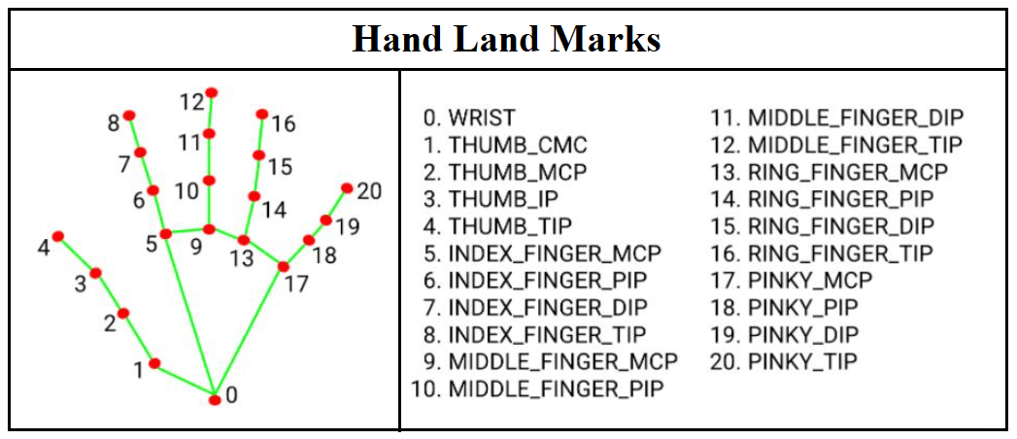

**2.4.2 Cursor Movement**

The cursor movement module is responsible for tracking the user’s hand position and translating it into the movement of the cursor on the screen. This is a foundational aspect of the virtual mouse system, as it ensures seamless and intuitive control over the cursor.

**Key Processes**

1. **Hand Tracking**
   * Using a webcam, the system captures a continuous video stream and identifies the user's hand in real-time.
   * The **Mediapipe Hand module** is employed to detect key landmarks on the hand, such as fingertips and the wrist. Mediapipe provides a set of 21 predefined points for hand landmarks, which are crucial for tracking the hand’s movement.
2. **Coordinate Mapping**
   * The detected hand position is mapped to screen coordinates using a Cartesian plane. The process involves:
     + **Normalization**:
       - The hand’s position in the video frame is normalized to ensure consistency regardless of the resolution of the camera or screen. For example, a detected position in a 1280x720 frame is scaled to match the screen’s resolution.
     + **Mapping to Cursor Coordinates**:
       - The normalized hand position is converted into coordinates on the computer screen, allowing the cursor to move accordingly.
     + **Coordinate Smoothing**:
       - To ensure smooth cursor movement, algorithms such as exponential moving averages are applied to filter out jitter or sudden changes in the hand’s position.
3. **Calibration for User Comfort**
   * The system allows calibration to account for variations in user comfort and camera positioning. For example, users may define an interaction zone or adjust the sensitivity of cursor movement to better match their hand gestures.
4. **Real-Time Responsiveness**
   * Achieving low latency in cursor movement is critical. Efficient processing with GPUs and optimized algorithms ensures that the cursor follows the hand’s movements almost instantaneously (typically under 100 ms).

**Challenges**

* **Background Interference**:
  + Dynamic or cluttered backgrounds can interfere with accurate hand tracking. The system mitigates this by focusing on detected hand landmarks rather than pixel-based detection.
* **Lighting Conditions**:
  + Variations in lighting can affect video quality. Adaptive techniques like histogram equalization are used to enhance the video feed in poor lighting.

**2.4.3 Gesture-Based Actions**

This module is designed to recognize predefined hand gestures and map them to mouse actions such as left-click, right-click, drag-drop, and scrolling. The module ensures that these gestures are intuitive, easy to perform, and reliably recognized.

**Key Features**

1. **Gesture Recognition**
   * **Hand Gestures for Mouse Actions**:
     + **Left-Click**: Thumb and index finger pinch together briefly.
     + **Right-Click**: Pinch with the thumb and middle finger.
     + **Drag and Drop**: Maintain a pinch (thumb and index finger) while moving the hand.
     + **Scroll**: Vertical hand movement while holding a specific gesture (e.g., a closed fist).
   * **Recognition Process**:
     + The system analyzes the positions of the hand landmarks detected by Mediapipe. For example:
       - A pinch gesture is identified when the distance between specific fingertips (e.g., thumb and index finger) falls below a threshold.
       - A scroll gesture is recognized when the hand moves up or down while maintaining a predefined configuration (e.g., closed fist).
     + Advanced algorithms classify these gestures based on landmark data and context (e.g., movement patterns).
2. **Execution of Mouse Actions**
   * Once a gesture is recognized, it is mapped to a corresponding mouse action using **PyAutoGUI**.
   * Example:
     + For a left-click, PyAutoGUI simulates a mouse click at the current cursor position.
     + For a drag-and-drop action, the system initiates a mouse button hold when the gesture starts and releases it upon gesture completion.
3. **Customization and Adaptability**
   * Users can customize gestures to suit their preferences. For example, a user might configure a different gesture for right-click if the default one is uncomfortable.
   * The system can adapt to individual variations in hand size, speed, and gesture performance.
4. **Robustness Across Scenarios**
   * The module is designed to handle:
     + **Dynamic Environments**: It works effectively even with moving backgrounds or other objects in the frame.
     + **Multiple Lighting Conditions**: Algorithms adapt to changes in lighting to ensure consistent gesture recognition.
   * Gesture detection and execution are optimized for diverse users, ensuring inclusivity and broad applicability.

**Challenges**

* **False Positives**: The system must ensure gestures are deliberate to avoid accidental actions. To address this, it includes:
  + A confidence threshold for gesture recognition.
  + Context-awareness to differentiate between random hand movements and intentional gestures.
* **Speed vs. Accuracy Trade-Off**: Balancing responsiveness with accurate gesture recognition is critical. Optimized algorithms ensure minimal latency without compromising reliability.

**End Goal**

The cursor movement and gesture-based actions modules work together to deliver a seamless and intuitive virtual mouse experience. The system ensures users can interact with their devices efficiently and naturally, with gestures translating into precise and responsive mouse actions.

**3. DESIGN**

The design phase lays the foundation for implementing a gesture-based virtual mouse system. It involves modeling the system, analyzing its requirements through use cases, and specifying the architecture and class design. This section explains how continuous hand gestures are modeled as discrete events to perform virtual mouse actions.

**Modeling in Gesture-Based Systems**

Gesture-based systems operate by detecting and interpreting continuous hand movements or gestures and converting them into discrete actions. For instance, a gesture like pinching the thumb and index finger is modeled as a **"left-click"** event. The system ensures smooth and accurate recognition of gestures, even when performed in rapid succession or under varying conditions.

The key principle involves **breaking down the user’s hand movements into recognizable units** (gestures), which are then translated into predefined actions for the virtual mouse.

* 1. **Use Case Model for Requirement Analysis**

The **use case model** provides a high-level overview of how users interact with the system. It identifies the actors involved, the functionalities provided, and the flow of operations.

**Actors**:

1. **Primary Actor**: The user controlling the virtual mouse through gestures.
2. **System**: The gesture-recognition software.

**Use Cases**:

1. **Cursor Movement**: The user moves their hand, and the cursor on the screen follows the motion.
2. **Left-Click**: The user performs a pinching gesture, and the system registers a left-click.
3. **Right-Click**: The user performs a different gesture (e.g., pinch with thumb and middle finger), triggering a right-click.
4. **Drag and Drop**: The user holds a pinch gesture and moves their hand to drag an object, releasing the gesture to drop it.
5. **Scrolling**: Vertical hand movements while performing a predefined gesture cause the system to scroll.

**Use Case Diagram:**

The diagram illustrates:

* The **user** initiating actions through gestures.
* The system’s responses, including cursor movement and mouse actions (click, drag, scroll).
* Arrows showing the flow of interactions between the user and the system.

**Figure 3.1: Use Case Diagram**

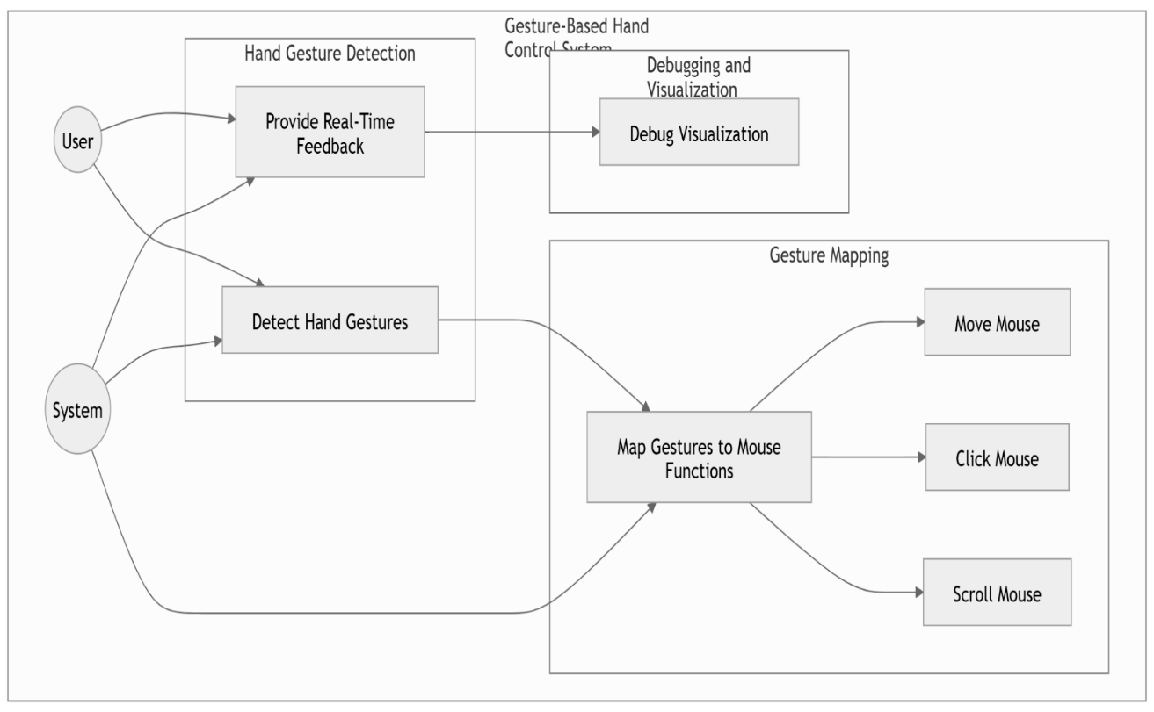

* 1. **Conceptual Architecture**

**Figure 3.2: Conceptual Architecture**

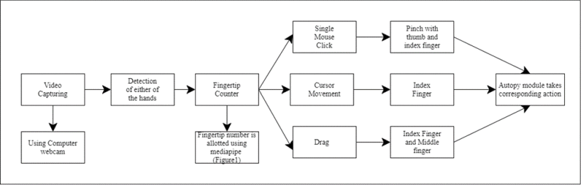

* 1. **Object and Class Design**

The object-oriented design identifies key classes and their interactions.

**Classes and Responsibilities**:

1. **HandTracker**:
   * **Responsibilities**:
     + Detect hand landmarks using Mediapipe.
     + Track hand positions and movement.
   * **Key Methods**:
     + detect_landmarks(video_frame): Identifies hand landmarks in a video frame.
     + track_hand_position(): Tracks the hand's position relative to the screen.
2. **GestureRecognizer**:
   * **Responsibilities**:
     + Identify specific gestures based on hand landmark configurations.
     + Distinguish between gestures like pinch, swipe, and hold.
   * **Key Methods**:
     + recognize_gesture(landmarks): Classifies gestures based on the detected landmarks.
     + get_action(): Maps the recognized gesture to an action (e.g., left-click).
3. **MouseController**:
   * **Responsibilities**:
     + Execute mouse actions based on recognized gestures.
     + Control cursor movement, clicks, drag-and-drop, and scrolling.
   * **Key Methods**:
     + move_cursor(position): Updates cursor position.
     + click(action_type): Simulates mouse clicks (left/right).
     + scroll(direction): Performs scrolling based on vertical hand movements.

**Figure 3.3: Class Diagram**

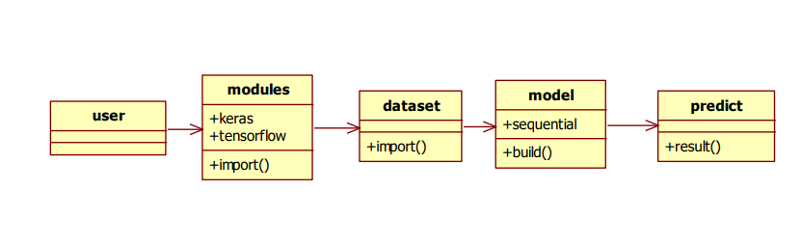

* 1. **Activity Diagram**

The activity diagram depicts the flow of actions in the system:

1. Capture video feed.
2. Detect hand landmarks.
3. Recognize gestures.
4. Map gestures to actions.
5. Execute mouse actions (move cursor, click, drag, scroll).

**Flow Details**:

* The process starts with the video stream input.
* Decision nodes check for specific gestures, ensuring only recognized actions proceed to execution.
* Loops handle continuous hand tracking for dynamic interactions like cursor movement or dragging.

**Figure3.4: Activity Diagram**

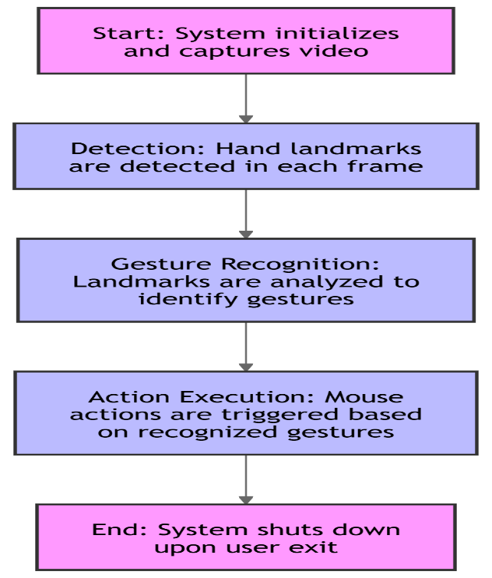

* 1. **Sequence Diagram**

The sequence diagram highlights the interactions between components over time:

1. The **user** initiates gestures captured by the webcam.
2. The **HandTracker** detects and forwards hand position data to the **GestureRecognizer**.
3. The **GestureRecognizer** classifies gestures and sends the action to the **MouseController**.

The **MouseController** performs the corresponding action, such as moving the cursor or clicking.

**Figure3.5: Sequence Diagram**

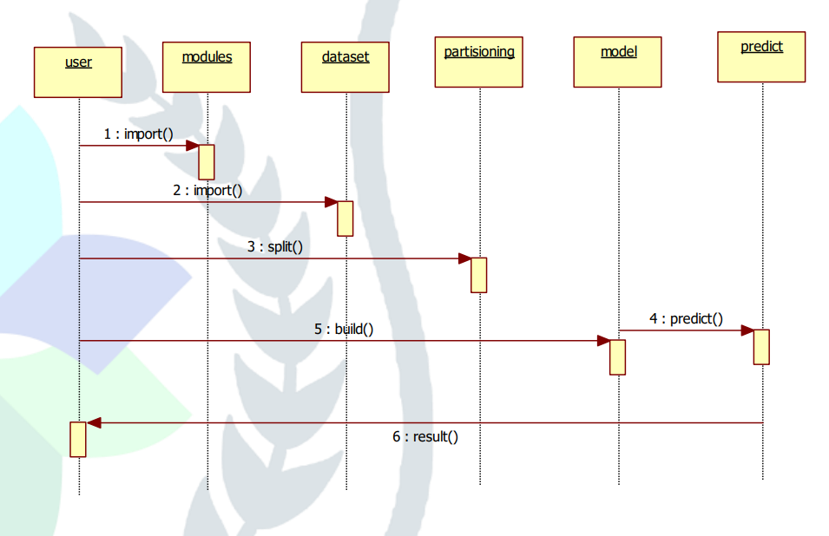

**4. SYSTEM COMPONENTS**

**4.1. Overview**

The virtual mouse system is a combination of hardware and software components that work together to enable gesture-based interaction with a computer.

1. **Hardware**:
   * **Camera**: The system uses a high-resolution webcam (minimum 720p) to capture live video input. The camera acts as the primary sensor for detecting and tracking hand gestures.
   * **Processing Unit**: A computer with a capable processor (preferably with a GPU) ensures smooth real-time processing of hand gestures, enabling responsiveness even with complex gestures.
2. **Software**:
   * Built on Python, the system leverages specialized libraries:
     + **OpenCV**: Handles video frame capture and image processing.
     + **Mediapipe**: Tracks and extracts hand landmarks from the video feed.
     + **NumPy**: Facilitates efficient mathematical operations for gesture recognition.
     + **PyAutoGUI**: Maps recognized gestures to mouse actions (clicks, drags, etc.).

Together, these components provide a seamless interaction framework for touch-free control.

**4.2. Gesture Recognition Algorithm**

The gesture recognition algorithm forms the core of the virtual mouse system. It ensures accurate detection of gestures and their translation into corresponding mouse actions.

**Step 1: Capture Video Stream**

* The system starts by accessing the webcam to capture a continuous stream of video frames.
* **Key Operations**:
  + Frames are extracted in real-time (e.g., 30 FPS) using **OpenCV**.
  + The resolution of each frame is adjusted to balance performance and accuracy.
  + Each frame is treated as an independent image for further processing.

**Code Example**:

python

import cv2

# Initialize webcam

cap = cv2.VideoCapture(0)

while True:

ret, frame = cap.read() # Capture a frame

if not ret:

break

cv2.imshow('Video Feed', frame) # Display the captured frame

if cv2.waitKey(1) & 0xFF == ord('q'): # Exit on pressing 'q'

break

cap.release()

cv2.destroyAllWindows()

**Step 2: Detect Hand Landmarks Using Mediapipe**

The system uses **Mediapipe’s Hand module** to detect and track 21 predefined landmarks on each hand, including the tips of the fingers, knuckles, and wrist.

* **Key Features of Mediapipe**:
  + Pre-trained deep learning models for high-speed, real-time hand tracking.
  + Robust to changes in lighting, backgrounds, and hand orientations.
* **Process**:
  + **Hand Detection**:
    - The module identifies regions in the video frame that likely contain a hand.
    - A bounding box is created around the detected hand.
  + **Landmark Localization**:
    - Within the detected hand region, the module identifies precise landmark points, such as the tips of the fingers and joints.
* **Output**:
  + A set of 21 3D coordinates for each detected hand. These coordinates represent the position of each landmark in the frame.

**Code Example**:

python

import cv2

import mediapipe as mp

# Initialize Mediapipe Hand module

mp_hands = mp.solutions.hands

hands = mp_hands.Hands(min_detection_confidence=0.7, min_tracking_confidence=0.7)

mp_drawing = mp.solutions.drawing_utils

# Capture video feed

cap = cv2.VideoCapture(0)

while True:

ret, frame = cap.read()

if not ret:

break

# Convert the frame to RGB (Mediapipe expects RGB input)

frame_rgb = cv2.cvtColor(frame, cv2.COLOR_BGR2RGB)

# Process the frame to detect hands

results = hands.process(frame_rgb)

# Draw hand landmarks

if results.multi_hand_landmarks:

for hand_landmarks in results.multi_hand_landmarks:

mp_drawing.draw_landmarks(frame, hand_landmarks, mp_hands.HAND_CONNECTIONS)

cv2.imshow('Hand Detection', frame)

if cv2.waitKey(1) & 0xFF == ord('q'):

break

cap.release()

cv2.destroyAllWindows()

**Step 3: Identify Gestures Based on Landmark Positions**

* The system analyzes the relative positions of hand landmarks to recognize specific gestures.
* **Example**:
  + A "pinch" gesture is identified when the distance between the thumb tip and index finger tip falls below a predefined threshold.
  + A "scroll" gesture involves the vertical motion of the wrist landmark while keeping the fingers stationary.
* **Mathematical Operations**:
  + **Distance Calculation**:
    - The Euclidean distance between two landmarks is computed to detect gestures like pinches.
  + **Angle Detection**:
    - Angles between landmark vectors can determine finger orientation and complex gestures.

**Step 4: Map Gestures to Predefined Actions**

Once a gesture is identified, it is mapped to a corresponding mouse action. This mapping is implemented using **PyAutoGUI**, which simulates mouse movements and clicks programmatically.

* **Examples of Mappings**:
  + **Left-Click**: A pinch gesture triggers a left mouse click.
  + **Right-Click**: A pinch involving the thumb and middle finger initiates a right-click.
  + **Drag and Drop**: A sustained pinch gesture allows the user to drag objects on the screen.
  + **Scroll**: Upward or downward wrist movements simulate scrolling.

**Code Example for Gesture Mapping**:

python

import pyautogui

# Example function for left-click action

def perform_left_click():

pyautogui.click()

# Example function for cursor movement

def move_cursor(x, y):

pyautogui.moveTo(x, y)

**Challenges Addressed**

1. **Dynamic Backgrounds**:
   * Mediapipe’s landmark detection ensures robust hand tracking regardless of background complexity.
2. **Lighting Variations**:
   * Histogram equalization techniques improve video quality under poor lighting conditions.
3. **Latency**:
   * Efficient algorithms ensure minimal delay, achieving near-real-time responsiveness.

**4.3. Flowchart of Gesture Recognition**

The flowchart represents the step-by-step process of recognizing hand gestures and mapping them to virtual mouse actions.

1. **Start**:
   * The system begins by initializing the camera and the required software frameworks like Mediapipe and OpenCV.
2. **Capture Video Frame**:
   * A continuous stream of video frames is captured using the webcam.
3. **Preprocess Frame**:
   * Convert the captured frame to the required format (e.g., BGR to RGB) for processing by Mediapipe.
   * Resize or normalize the frame for faster and more efficient computation.
4. **Detect Hand Landmarks**:
   * Mediapipe’s Hand module processes the preprocessed frame to detect hand landmarks.
   * If a hand is detected, the system identifies 21 distinct points, including fingertips, knuckles, and the wrist.
5. **Recognize Gestures**:
   * Analyze the positions and relationships of landmarks to classify gestures (e.g., pinch, open hand).
6. **Map to Actions**:
   * Match the recognized gesture to a predefined mouse action, such as left-click, right-click, drag, or scroll.
7. **Execute Action**:
   * Use PyAutoGUI to simulate the corresponding mouse action.
8. **Repeat**:
   * Continue processing frames until the system is stopped.

**Figure 4.1: Flowchart of Gesture Recognition**

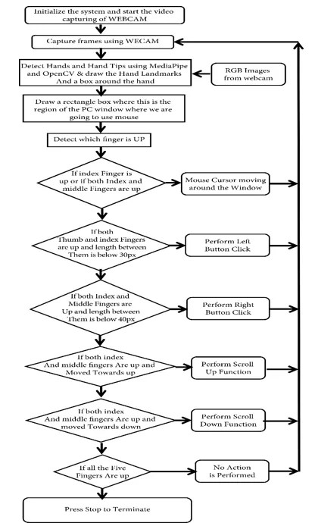

**5. IMPLEMENTATION**

The implementation phase transforms the design and system architecture into functional modules. The system is programmed to process video input, detect gestures, and simulate mouse actions based on user hand movements.

**5.1 Cursor Movement**

The cursor movement is implemented by mapping the detected hand’s position to the screen coordinates using a Cartesian coordinate system. The steps are:

1. **HandDetection**:  
   Mediapipe identifies the hand and extracts 21 landmarks. The key landmark for cursor movement is the tip of the index finger.
2. **CoordinateExtraction**:  
   The x and y coordinates of the index fingertip (landmark 8) are extracted and normalized to a range of 0 to 1 based on the frame dimensions.
3. **Screen Mapping**:
   * Normalize the extracted coordinates to match the resolution of the user's screen.
   * Use PyAutoGUI to move the mouse cursor to the corresponding position.

**Implementation**:

python

import pyautogui

import mediapipe as mp

import cv2

# Initialize Mediapipe Hands and PyAutoGUI

mp_hands = mp.solutions.hands

hands = mp_hands.Hands(min_detection_confidence=0.7, min_tracking_confidence=0.7)

cap = cv2.VideoCapture(0)

screen_width, screen_height = pyautogui.size()

while True:

ret, frame = cap.read()

if not ret:

break

frame_rgb = cv2.cvtColor(frame, cv2.COLOR_BGR2RGB)

results = hands.process(frame_rgb)

if results.multi_hand_landmarks:

for hand_landmarks in results.multi_hand_landmarks:

# Extract fingertip coordinates

x = hand_landmarks.landmark[mp_hands.HandLandmark.INDEX_FINGER_TIP].x

y = hand_landmarks.landmark[mp_hands.HandLandmark.INDEX_FINGER_TIP].y

# Map to screen coordinates

cursor_x = int(x * screen_width)

cursor_y = int(y * screen_height)

# Move the cursor

pyautogui.moveTo(cursor_x, cursor_y)

cv2.imshow("Virtual Mouse", frame)

if cv2.waitKey(1) & 0xFF == ord('q'):

break

cap.release()

cv2.destroyAllWindows()

**5.2 Gesture-Based Actions**

Predefined gestures are implemented to trigger specific mouse actions. The system detects these gestures based on the relative positions of hand landmarks.

**1. Left-Click**

**Gesture**: Pinch gesture with the thumb and index finger touching.  
**Implementation**:

* Monitor the distance between the thumb tip (landmark 4) and index finger tip (landmark 8).
* If the Euclidean distance falls below a threshold, simulate a left mouse click.

python

Copy code

import math

def calculate_distance(landmark1, landmark2):

return math.sqrt((landmark1.x - landmark2.x) ** 2 + (landmark1.y - landmark2.y) ** 2)

distance = calculate_distance(hand_landmarks.landmark[mp_hands.HandLandmark.THUMB_TIP],

hand_landmarks.landmark[mp_hands.HandLandmark.INDEX_FINGER_TIP])

if distance < 0.02: # Threshold for detecting pinch

pyautogui.click()

**2. Right-Click**

**Gesture**: Pinch gesture involving the thumb and middle finger.

**Implementation**:

* Calculate the distance between the thumb tip (landmark 4) and middle finger tip (landmark 12).
* If the distance is below a threshold, simulate a right mouse click.

python

Copy code

distance = calculate_distance(hand_landmarks.landmark[mp_hands.HandLandmark.THUMB_TIP],

hand_landmarks.landmark[mp_hands.HandLandmark.MIDDLE_FINGER_TIP])

if distance < 0.02: # Threshold for detecting pinch

pyautogui.rightClick()

**3. Drag**

**Gesture**: Continuous pinch gesture with movement.  
**Implementation**:

* Monitor the pinch gesture with the thumb and index finger.
* While the pinch gesture is active, continuously move the cursor to the detected position to simulate dragging.

python

if distance < 0.02: # Detect pinch

pyautogui.mouseDown()

pyautogui.moveTo(cursor_x, cursor_y)

else:

pyautogui.mouseUp()

**5.3 Scenarios**

The system’s performance is evaluated under various scenarios to ensure robustness and usability.

**Scenario 1: Cursor Movement Without Obstacles**

**Environment**:

* The user operates the system in a clean background with minimal distractions.
* The hand movements are unobstructed, and lighting is even.

**Outcome**:

* Smooth and accurate cursor tracking.
* Minimal latency in mapping hand movements to cursor motion.

**Scenario 2: Cursor Movement with Obstacles**

**Environment**:

* The system operates in a cluttered background with multiple objects or varied lighting.
* Obstacles like shadows or overlapping objects may interfere with hand detection.

**Outcome**:

* The system adapts using robust Mediapipe algorithms to filter noise.
* While accuracy might reduce slightly, the cursor movement remains functional.

**Mitigation Strategies**:

1. Employ additional preprocessing steps, such as background subtraction, to isolate the hand.
2. Use dynamic thresholds for gesture detection based on environmental factors.

**6. LIMITATIONS AND FUTURE ENHANCEMENTS**

This section addresses the challenges faced by the current system and proposes improvements for future iterations to enhance its robustness and usability.

**6.1 Limitations**

**1. Performance in Low-Light Conditions**

* **Issue**: The system relies on a webcam to capture hand gestures. In low-light environments, the quality of captured video frames deteriorates, leading to reduced accuracy in hand detection and gesture recognition.
* **Reason**: Mediapipe and similar computer vision algorithms depend on clear input to detect hand landmarks effectively. Poor lighting reduces contrast and introduces noise, making detection unreliable.
* **Impact**: Users may experience delays, misclassification of gestures, or system failure in dimly lit environments.

**Mitigation Strategies**:

* Introduce infrared-based cameras or external lighting setups.
* Implement histogram equalization or brightness adjustment filters to preprocess video frames for better clarity.

1. **Background Complexity**

* **Issue**: In environments with cluttered or dynamic backgrounds (e.g., moving objects, patterned walls), the system may struggle to isolate the hand.
* **Reason**: The presence of background features with colors or textures similar to the user’s skin tone confuses the hand detection algorithm.
* **Impact**: Reduced gesture recognition accuracy and possible false positives.

**Mitigation Strategies**:

* Use color segmentation or background subtraction techniques to isolate the user’s hand more effectively.
* Implement adaptive algorithms that focus on movement or shapes unique to the hand.

**6.2 Future Enhancements**

**1. Use Depth Sensors (e.g., Intel RealSense)**

* **Overview**: Depth sensors provide three-dimensional data by capturing not just the visual appearance but also the distance of objects from the camera.
* **Benefits**:
  + **Improved Accuracy**: Depth information enhances hand detection, even in cluttered or low-light environments.
  + **Gesture Differentiation**: Enables recognition of gestures involving depth, such as pushing or pulling actions.
  + **Background Independence**: Depth sensors can isolate the hand from the background effectively.

**Proposed Integration**:

* Replace or complement the existing webcam with a depth sensor like Intel RealSense or Microsoft Kinect.
* Modify the gesture recognition algorithm to incorporate depth data for more robust detection.

**Example Use Case**:  
A pinch gesture can be recognized in 3D space, with additional actions mapped to the depth of the pinch (e.g., scrolling as the fingers move closer or farther).

1. **Add Voice Control Integration**

* **Overview**: Voice control allows users to combine speech commands with hand gestures for more versatile and efficient interaction.
* **Benefits**:
  + **Hands-Free Functionality**: Users can trigger complex commands without additional gestures.
  + **Accessibility**: Supports users with limited hand mobility or precision.

**Proposed Features**:

* Combine voice input with gesture detection for context-sensitive actions.
  + Example: Saying “Drag” while performing a pinch gesture initiates a drag-and-drop action.
* Use Natural Language Processing (NLP) libraries like SpeechRecognition or Vosk for real-time voice processing.

**Implementation Example**:

python

import speech_recognition as sr

# Initialize recognizer

recognizer = sr.Recognizer()

with sr.Microphone() as source:

print("Say a command:")

audio = recognizer.listen(source)

try:

command = recognizer.recognize_google(audio)

print(f"You said: {command}")

if "click" in command.lower():

pyautogui.click()

elif "right click" in command.lower():

pyautogui.rightClick()

except sr.UnknownValueError:

print("Could not understand the command.")

1. **Optimize the System for Mobile Devices**

* **Overview**: Adapting the virtual mouse system for smartphones and tablets can broaden its usability and reach. Mobile devices, equipped with powerful cameras and processors, are suitable platforms for gesture-based systems.
* **Benefits**:
  + **Portability**: Extends the system’s usability to environments without traditional computers.
  + **Wider Adoption**: Makes the technology accessible to a broader user base, especially in regions where mobile devices are more prevalent than PCs.

**Challenges**:

* **Limited Resources**: Mobile devices have constraints on processing power and battery life.
* **Platform Diversity**: Different operating systems (Android, iOS) require separate development frameworks.

**Proposed Solutions**:

* Use lightweight machine learning models optimized for mobile platforms, such as TensorFlow Lite or ONNX Runtime.
* Leverage mobile-specific libraries, like Google’s Mediapipe for Android/iOS or ML Kit.
* Implement background execution for real-time gesture recognition with minimal battery usage.

**Example Use Case:**A smartphone camera tracks the user’s hand movements, enabling touchless control of apps, scrolling, or media playback.

**7. CONCLUSION**

The development of a virtual mouse system controlled by hand gestures demonstrates the transformative potential of touchless technologies in human-computer interaction. This project integrates advancements in computer vision, gesture recognition, and real-time processing to replace traditional input devices like physical mice. The system’s implementation and functionality highlight its practicality and ability to address specific needs in modern interaction paradigms.

**Key Takeaways**

1. **Practicality of Gesture Control**:  
   This project successfully validates the use of hand gestures as a practical alternative to hardware-based input devices. By detecting and interpreting predefined gestures such as pinching for clicks or continuous movement for dragging, the virtual mouse system achieves core functionalities required for seamless navigation and interaction.
2. **Technological Advancements Leveraged**:  
   The project capitalizes on state-of-the-art technologies, including:
   * **Computer Vision**: Using tools like OpenCV for video processing.
   * **Gesture Recognition Frameworks**: Mediapipe's hand tracking module for detecting hand landmarks with precision.
   * **Automation Libraries**: PyAutoGUI for mapping gestures to mouse actions.  
     These technologies collectively deliver real-time performance with minimal latency, demonstrating the robustness of modern computational tools.
3. **Touchless Interaction**:  
   The touchless nature of the virtual mouse provides a hygienic alternative, especially valuable in environments where reducing physical contact is essential, such as healthcare, public kiosks, or shared workstations.
4. **Accessibility and Inclusivity**:  
   By eliminating the need for physical input devices, the system enhances accessibility for users with limited mobility or physical impairments, offering a means of control through intuitive gestures.
5. **Innovation in User Interfaces**:  
   The virtual mouse aligns with emerging trends in user interface design, showcasing how natural and intuitive input methods like gestures can redefine how users interact with digital systems.

**Applications Across Domains**

The touchless virtual mouse system has potential applications in a variety of fields:

* **Healthcare**: Enables sterile and touch-free interaction with medical devices or systems during surgeries or procedures.
* **Gaming**: Offers a more immersive and dynamic way of controlling in-game actions.
* **Education and Presentations**: Facilitates seamless control over slides or interfaces during remote and in-person sessions.
* **Assistive Technology**: Serves as a powerful tool for individuals with disabilities, providing alternative ways to navigate digital environments.

**Limitations and Learning Opportunities**

While the project demonstrates the potential of gesture-based systems, it also highlights areas for improvement:

* **Environmental Dependencies**: The system’s performance can be affected by lighting conditions and background complexity, which future iterations can address through advanced preprocessing or hardware upgrades.
* **Gesture Range**: The current implementation supports a limited set of predefined gestures. Expanding the gesture vocabulary can make the system more versatile.

These challenges are not barriers but opportunities for further exploration and innovation.

**Future Directions**

This project sets the foundation for future research and development in gesture-based technologies. Potential directions include:

1. Integrating depth sensors for enhanced gesture detection and 3D interaction.
2. Combining voice commands with gestures for multimodal interaction.
3. Optimizing the system for mobile and wearable devices to increase portability and accessibility.

**8. REFERENCES**

1. **OpenCV Documentation**: Comprehensive guide and reference for OpenCV functions and modules used for computer vision tasks.
2. **Mediapipe Framework by Google**: Documentation and resources for hand tracking and gesture recognition models.
3. **PyAutoGUI Library Documentation**: Python library for programmatically controlling the mouse and keyboard.
4. **Research Papers on Hand Gesture Recognition**: A collection of scholarly articles detailing algorithms and techniques for gesture recognition. Examples: IEEE Xplore, SpringerLink, or Elsevier journals.
5. **Python.org**: Resources and documentation for Python, the primary programming language used in the project.
6. **Numpy Documentation**: Python library for numerical computing and array manipulation, used extensively in image processing.
7. **"Real-Time Hand Gesture Recognition Using Mediapipe and OpenCV"**: Research article outlining the integration of Mediapipe for gesture-based applications.